###### Apartment Rental System

Software Requirements Document

Version: 1.0

Date: December 6, 2015

###### Prepared by

Faheem Syed

**Table of Contents**

1. Preface 4

1.1. Modification History 4

1.2. Intended Audience 4

2. Introduction 4

3. Glossary 4

4. User Requirement Definition 4

5. System Requirements Specification 5

6. System Architecture 5

7. System Models 5

7.1. Use Case Diagram 5

7.2. Sequence diagram 5

7.3. Class diagram 5

8. System Evolution 5

9. Appendices 5

10. Index 5

**Table of Figures**

# Preface

This document, Software Requirements Specification (SRS), is created to document the software requirements for the Apartment Rental System, as described in section 2, Introduction, of this document

## Modification History

|  |  |  |  |
| --- | --- | --- | --- |
| **Date** | **Version** | **Author** | **Summary of changes** |
| 12/06/2015 | V1.0 | Faheem Syed | Started document |
|  |  |  |  |
|  |  |  |  |

## Intended Audience

This document is intended for all stakeholders of the effort.

# Introduction

## Purpose of the requirements document

The purpose of this Software Requirements Document (SRD) is to present a detailed description of the Apartment Rental System (ARS). It will explain the purpose and features of the system, the interfaces, as well as what the system will do. This SRD is intended for both the stakeholders and the developers of the system.

## Scope of the product

This is a basic system that will keep a record of apartments available for rent in the New York City area, the system will work as a connecting bridge between customers and property sellers. This system will ease the search for apartments for potential buyers as well as provide property owners with a larger audience than traditional methods. It will minimize apartment search and sell times for customers and sellers respectively.

More specifically, the Apartment Rental System is designed to allow buyers to see potential homes in much more detail than contacting sellers and seeing apartments in person. It will also allow sellers to post their apartments with minimal effort and cost to them as well as be contacted through email and telephone.

## Reference

## Overview of the reminder of the document

# Glossary

Define technical terms used in the document.

|  |  |
| --- | --- |
| **Term** | **Meaning** |
| Listing | A posting for an apartment including the location of the apartment, price, number of bedrooms, bathrooms as well as a picture. |
| Product users | These are users who interact with the system directly. For instance, employees- supervisors, project managers, project engineers and admin. |
| Buyer, Customer | These are users who interact with the system directly in attempt to find an apartment for rent. |
| Seller, Property owner | These are users who interact with the system directly that use their system to advertise and rent out their property. |

# User Requirement Definition

The user (buyer) is expected to be Internet literate and be able to use a simple search engine. The home page of the Apartment Rental System will have a search feature where the user will type in the location, either city or zip code, to search for apartments available for rent in that specific area. Leaving the search bar blank will show all results from the system database. The process for the seller is similar as well with the seller being required to fill in blanks for posting apartment description, contact info and uploading pictures.

# System Requirements Specification

This should describe the functional and nonfunctional requirements in more detail. If necessary, further detail may also be added to the non-functional requirements, e.g. interfaces to other systems may be defined.

**Functional Requirements**

* Register (sign up): The system will allow new users to sing up for a sellers or buyers account. First name, last name, email, and phone number will be required to sign up.
* Log in/Log out: The system will allow returning users to log in. This will give buyers access to listings and sellers will get the ability to post new, update or delete listings.
* Home: The system will allow the user to enter specific locations, bedrooms, bathrooms, price in their respective fields for a much more desired result.
* Search Listings: The system will display the listings of apartments for rent.
* Rent: The system will provide the sellers contact information for renting an apartment
* Update Listings: The system will allow sellers to add, edit/update or delete their listings.

**Non-Functional Requirements**

The Apartment Rental System Database will be held on an online server with high speed internet capability. The database will hold listings and allow sellers to create new, update and delete listings as well as allow buyers to view the listings.

# System Architecture

The Apartment Rental System uses a Multi Layer Architectural Model. A windows based user logs on, using our application, which connects to our data servers to request relevant searches.

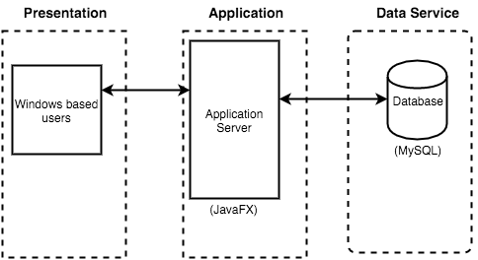

# System Models

## Use Case Diagram

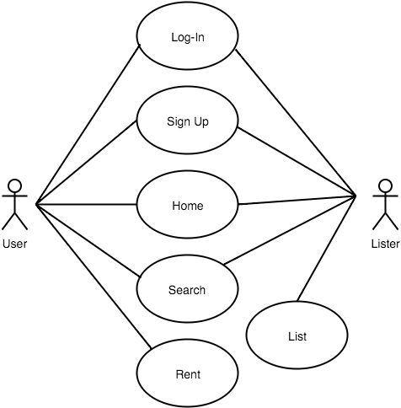

See **Functional Requirements** in **section 5** (**System Requirement Specification**) for an in-depth text description of the Use Case diagram.

## Sequence diagram

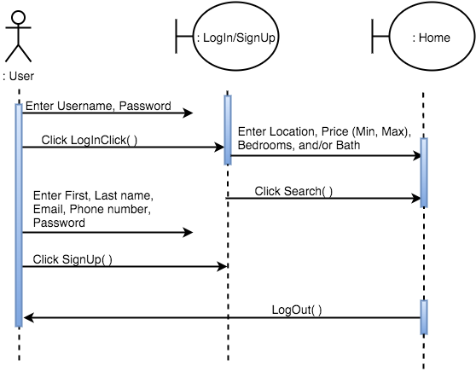

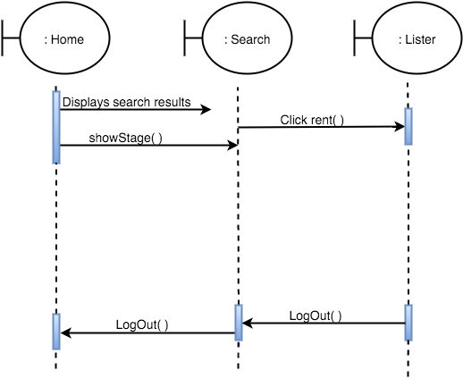

## Class diagram

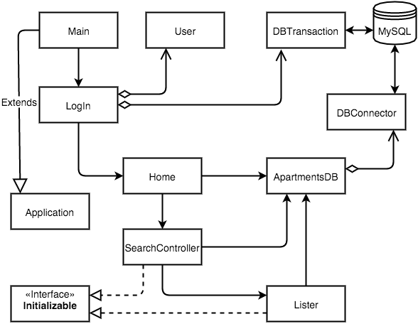

# System Evolution

Describe the fundamental assumptions to which the system is based and anticipated changes due to hardware evolution, changing user needs, etc…

The System will need a web based client due to immense public use of the internet. A web based client will only need the design and deployment of a website, the same databases can be used.

The System will also require the need for a mobile application due to the astounding growth of mobile platforms. This will require the use of multiple different OS (iOS, Android, Windows Mobile) as well as integration with other existing clients (Application based, Web based).